

**Lebanese American University**

**School of Engineering**

**E.C.E Department**

Yogeroo

Capstone Design Project 2 Report

Fall 2020

Jean-Michel Rizk 201502387

Elie Al Osta 201502594

Raed Kridly 201501883

Supervised by: Dr. Dani Tannir

# Abstract

The purpose of this project is to develop an automated frozen yogurt machine. This system will be used to reduce the cost of Man labor and to be able to place such types of vending machines more frequently in airports and universities. In this report, we present our research and work done in order to implement our vision of an automated frozen yogurt dispenser. This model could be reused to automate multiple types of businesses into reducing Man labor in the future. In order to provide the above-mentioned functionalities, the system consists of multiple dispensers and an interface to interact with the machine and a monetary system. In this report, we will be discussing all the different technologies and path we decided to take in order to implement our automated system.

Table of Content

Abstract 2

Table of figures 5

Table of Tables 6

Introduction 7

Overview 7

Problem 7

Approach 8

1. Brainstorming 8

2. Feasibility Study 8

3. Design study 8

Projects Constraints and Standards Utilized 9

Background 11

Vending machine and Frozen yogurt machines 11

Nema stepper motors 11

UART communication 11

HACCP 12

Project designs 13

1. Cup movement 13

Conveyor Belt: 13

Robotic arm-based ice cream machine: 20

An autonomous ice-cream serving robot: 22

2. Dispensers 23

Features of the Ultrasonic Distance Sensor: 26

Operation of strain gauge Load cell 28

Let study the operation in two cases 28

3. Interface 29

Raspberry pi 29

Arduino 29

4. Scanning Barcode 30

Barcode scanner 30

Camera 30

Controllers 31

Raspberry pi 3 B+ 31

PIC16F887 33

Results 35

SolidWorks Design 35

Implementation 37

Dispenser 37

LCD 43

Ultrasonic 45

Relay 46

PIC 46

Code 49

Conveyor belt 52

Interface 55

Pricing 62

Conclusion 64

Bibliography 65

# Table of figures

Figure 1: Image of the UART communication 13

Figure 2: Conveyor belt design 16

Figure 3: Conveyor belt module 16

Figure 4: Pros and Cons of the conveyor belt 17

Figure 5: infra-red sensor 18

Figure 6: pros and cons of infra-red 18

Figure 7:Nema17 stepper motor Figure 8:Nema23 stepper motor 19

Figure 9: Denso motor 20

Figure 10: Robotic Arm 21

Figure 11:ESP8266 Wi-Fi module 22

Figure 12: pros and cons for the robotic arm 23

Figure 13: Pros and Cons of the autonomous ice-cream serving robot 24

Figure 14: Dispenser design 1 25

Figure 15: Dispenser design 2 25

Figure 16 Design 2 26

Figure 17 Ultrasonic Sensor 27

Figure 18 Strain Gauge load Cell 28

Figure 19 Wheat Stone Bridge 29

Figure 20: Raspberry pi code flowchart 33

Figure 21: PIC code flowchart 34

Figure 22: Vending machine viewed from the top right 36

Figure 23: Vending machine viewed from the top 37

Figure 22 Ariete Specification 38

Figure 23 Ariete with servo Figure 24 Top view of Ariettes servo 39

Figure 25 Container opened Figure 26 Container Closed 40

Figure 27 Cutting steel 41

Figure 28 Assembly 41

Figure 29 MG995 servo 42

Figure 30 control ice cream maker 43

Figure 31 control topping dispenser 44

Figure 34: LCD typical code 46

# Table of Tables

Table 1: Project Constraints 11

Table 2: Standards used for the project 11

Table 3: Specifications of the Denso motor 20

Table 4: total pricing 64

# Introduction

## Overview

In today’s world, almost everybody loves a good yogurt. But even more than that, everybody loves a delicious frozen yogurt with even more delicious toppings. Now here lay both the problem and the opportunity. When hurrying employees or careless customers have to serve yogurt toppings (or any other thing for that matter), they tend to create a mess. This mess may include spills of toppings, oversized servings that result in waste, and the like. If only there was a solution to prevent these ails and offer even more benefits?

Modern life requires things to be efficient, quick, and simple. With so much to see and do people aren’t interested in wasting time. They expect to get what they need, when they need it, in the exact amount they need it.

## Problem

Although nowadays vending machines are present in our everyday lives for the snacks, coffee, sodas, and water somehow it seems that the use of vending machines has stopped there. It may seem unnecessary to develop more types of vending machines but it is a great type of selling point in a crowded area of passage, such as university campuses or public transportation hot spots. The greatest advantage a vending machine has is it can be transported and placed in other spots to change customers, while actually opening an ordinary selling point requires a bigger investment and cannot change its location so easily.

Regarding our type of vending machine some solutions are already available in foreign country’s, unfortunately, they are selling for an exorbitant amount of money, making it quite impossible to make the amount of frozen yogurt vending machine grow. Our main goal in this project is to create a product that can deliver similar results but with a different price tag. Also hopefully our technology could be used to deliver multiple types of goods through vending machines.

## Approach

### Brainstorming

To create a solution that delivered the same results at a different cost we started doing some research and thinking about new ideas to create our system. Multiple ideas were found to treat the problem at hand, but we knew the further study was needed to decide which one to work on.

### Feasibility Study

Once all of the ideas were given, we had to decide which were most plausible to work, especially in terms of feasibility due to multiple factors to take into consideration such as time (deadlines to respect) and workload. Two options quickly arose above from the rest, one where we were going to attempt to recreate the system already available in ways to minimize the cost and another where the approach was completely different and innovative. Both options will be discussed in a greater manner in further sections.

### Design study

In every project, before going all out and starting to test and try to build any type of pre-prototype a plan of work should be designed first. All of the different stages and goals for each option should be laid out to be able to research well and know where we may find some difficulties of any sort in the future while working on the project

# Projects Constraints and Standards Utilized

|  |  |
| --- | --- |
| **Constraint** | **Description** |
| **Cost** | The total cost of the prototype should be kept to a minimum. This cost will cover all the different  Blocks of our project:  • Frozen yogurt dispenser  • Sensors  • Camera  • Touch-screen  • Conveyor belt • Dispensers This project is a prototype that should not cost more than 500$. However as the frozen yogurt  machine installed will be chosen as a home dispenser, so in the future to actually launch the  project will cost a lot more as professional frozen yogurt dispensers are very expensive. |
| **Latency** | This device is not required very rapid execution and delivers the frozen yogurt cup extremely fast  but it should also be delivered in an amount of time that is acceptable. |
| **Accuracy** | The conveyor belt control should be very accurate as when the cup reaches the ideal position  under the dispenser then the conveyor belt should stop. Any error inaccuracy could lead to  spills on the conveyor and unhappy customers. |
| **Size** | This product should not be too large in size, as it is a vending machine. Maximum size should be  below 1m^3. |
| **Availability** | The local market may not have all options of sensors or controllers, motors, touchscreens,…  So some of the design paths may be chosen due to availability. |
| **Usability** | The user interface should be user-friendly to ensure good customer service. |
| **Hygiene** | All of the dispensers and especially the frozen yogurt dispenser should be able to be  dismounted easily to clean the dispensers. All of these should be followed for sanitary rules  such as the HAACP |

Table 1: Project Constraints

|  |  |
| --- | --- |
| **Standard** | **Implementation** |
| **ISO (the International Organization for Standardization)/ CEN (Committee European de Normalization)** | Creation of the conveyor belt with all its components (rollers, belts, bolts and pulleys). |
| **HACCP( Hazard Analysis Critical Control Points)** | Cleaning the dispensers and especially the frozen yogurt dispenser. |
| **UART( Universal Asynchronous Receiver-Transmitter)** | Communication between the PIC and the Controller. |

Table 2: Standards used for the project

# Background

## Vending machine and Frozen yogurt machines

The idea behind vending machines was introduced back in the late nineteenth century, and since then it has seen great success in our world. Our inspiration came out from the actual ice cream machine found online and from articles read about [Generation Next Franchise Brands, Inc. (VEND)](https://seekingalpha.com/symbol/VEND) written by White Diamond Research and an article written by Lana Bandoim (freelance writer) entitled “Robotic Vending Machines Want To Feed You Frozen Yogurt”. These approaches were based on a robotic arm that will be elaborated in this report; however, we looked to create something unique and efficient combining the frozen yogurt machine with a flat conveyor belt. This idea was inspired from a research written by M. Kamalakannan and K. Devadharshini about Controlling the Speed of Conveyor Belt using Python in the oriental Journal of Computer Science and Technology which includes a precise calculation for an efficient design.

## Nema stepper motors

Nema (National Electrical Manufacturers Association) which is a rating that is used as a standard to define the types of environments where an electrical device can be used. Nema motors are usually stepper motors which are a type of control motors that can get on speed control and positioning control without using a feedback loop, which is the so-called open-loop motor control. Its application mainly focuses on OA (Office Automation) machines and FA (Factory Automation) machines that solve strong office services and is widely used in medical machinery, measuring instruments, cars, and game machines, CNC machines, and 3 D printing machine industries. For more information on the subject please refer to the reference [11].

## UART communication

UART stands for Universal Asynchronous Receiver/Transmitter. It’s not a communication protocol like SPI and I2C, but a physical circuit in a microcontroller, or a stand-alone IC. A UART’s main purpose is to transmit and receive serial data. In UART communication, two UARTs communicate directly with each other. The transmitting UART converts parallel data from a controlling device like a CPU into serial form, transmits it in serial to the receiving UART, which then converts the serial data back into parallel data for the receiving device. Only two wires are needed to transmit data between two UARTs. Data flows from the Tx pin of the transmitting UART to the Rx pin of the receiving UART:

[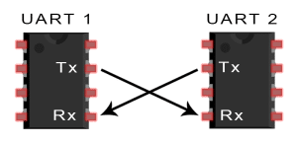](http://www.circuitbasics.com/wp-content/uploads/2016/01/Introduction-to-UART-Basic-Connection-Diagram.png)

Figure : Image of the UART communication

UARTs transmit data asynchronously, which means there is no clock signal to synchronize the output of bits from the transmitting UART to the sampling of bits by the receiving UART. Instead of a clock signal, the transmitting UART adds start and stop bits to the data packet being transferred. These bits define the beginning and end of the data packet so the receiving UART knows when to start reading the bits. For more information on the subject please refer to the reference [4].

## HACCP

The HACCP (Hazard Analysis Critical Control Points) is a system that should be followed by all of the food industry. It is a preventative food safety system that takes stock of the hazards in food. The rules were set by the European Union and it is made in a way that the food industries must apply the system onto their own; they should identify the potential hazards themselves and make sure to eliminate them as much as possible. The main hazards to take into consideration are the ones that could present a risk at a food safety level. This may include some microbiological bodies such as viruses and bacteria. For more information on the subject please refer to the reference [7].

# Project designs

In this part of the report, we will be discussing the design of the 3 main blocks of our project and the diverse solution we thought of for each block, as well as what solution we chose and why we chose it. First, we will be discussing the cup movement (how the cup be will be traveling from one dispenser to the other until it reaches the customer). Second, we will be discussing the design of the dispensers and how to discharge its contents into the cup. Third, we will be discussing the user interface and how it will be implemented. Finally, we will be discussing the barcode scanning part and how the monetary system will be created.

## Cup movement

### Conveyor Belt:

The conveyor belt design used in our design is a simple horizontal flat Belt conveyor system. This type was used as its ideal for transporting light- and medium-weight loads between operations and Provides considerable control over the orientation and placement of the load. With No smooth accumulation, merging, and sorting on the belt.

In order to study the conveyor belt and estimate the power of the motor we need first of all to take into consideration the tension at steady state (Tb):

Tb=1.37*f*L*g*[2*mi+ (2*mb + mm) *cos (δ)] + (H*g*mm)

Where:

Tb is in Newton.

f = Coefficient of friction approximated to 0.64(iron)

L = Conveyor length in meters (approximately half of the total belt length)

g = Acceleration due to gravity = 9.81 m/sec2

mi = Load due to the idlers in Kg/m.

mb = Load due to belt in Kg/m.

mm = Load due to the conveyed materials in Kg/m. (depends on the material we find in the market)

δ = Inclination angle of the conveyor in Degree.in our design there is no inclination

H = vertical height of the conveyor in meters, only horizontal

Load due to idlers (mi): This can be calculated as below:

mi = (mass of a set of idlers) / (idlers spacing) (in our design we used only 2 idlers because a small distance was covered)

To finally find ­­­ in order to estimate the motor power

Pp = (Tb*V)/1000

In order to estimate the motor power

In our application, the speed of the operation is not as important as accuracy.

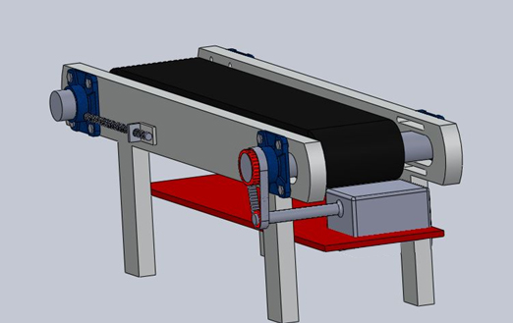

Figure : Conveyor belt design

.

Figure : Conveyor belt module

Figure : Pros and Cons of the conveyor belt

Controlling the belt mechanism will be done by installing an IR sensor or an ultrasonic sensor at the very end of the conveyor belt. The decision will be taken later depending on other factors. The distance from the end of the belt to each dispenser will be memorized and each time we encounter a memorized distance the PIC will send a signal to the motor to stop it for 8-12seconds in order for the dispenser to drop the ingredient in the cup and then move on to the next dispenser. It will have 4 memorized positions, and the distance traveled by each cup will be similar, however, the timing will differ.

#### Infra-red sensor:

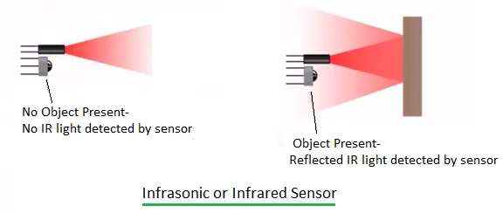

Figure : infra-red sensor

Figure : pros and cons of infra-red

#### The Motor:

To rotate the whole apparatus, we could use a 12v Nema17-Nema23 bipolar stepper motor, for very high precision. For our application, a Nema23 would have been needed to move with a good speed/torque however it’s not available in Lebanon and needed to be purchased online.

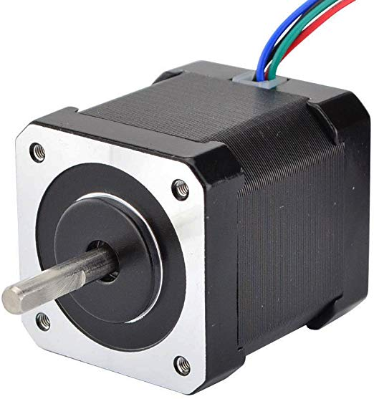 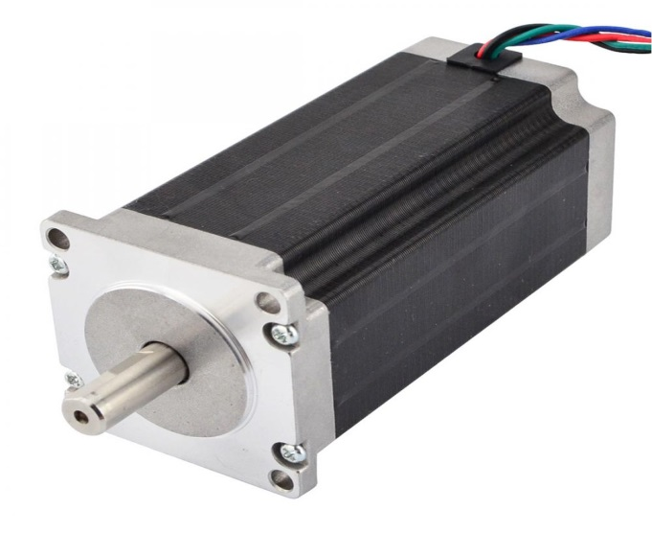

Figure :Nema17 stepper motor Figure :Nema23 stepper motor

According to the calculations, Nema17 wouldn’t produce the power needed without a gearbox as the system requires a high starting torque/power according to the following equation:

Tbs =Tb*Ks (in N)

Where,

Tb = the steady-state belt tension in N.

Ks = the start-up factor which is usually taken 1.5

Therefore, we will be using the Denso motor as it is already available and produce a very high torque (with gearbox) and good accuracy

Denso’s specifications:

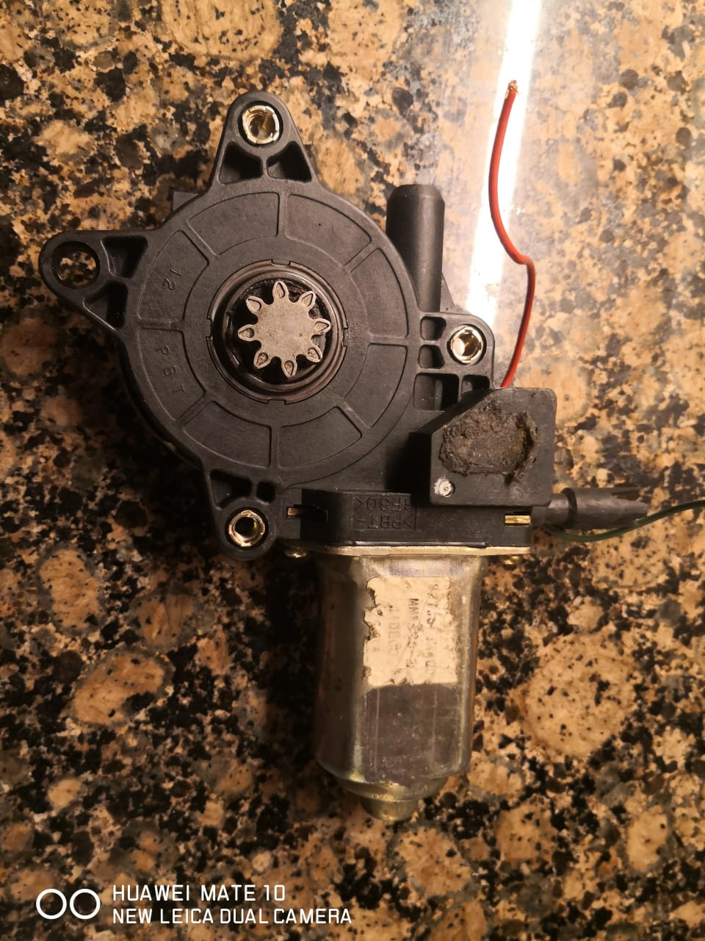

Figure : Denso motor

|  |  |
| --- | --- |
| Stall current (amps) | 24.8 |
| Stall torque (in-lb) | 81.4 (9.2 N-m) |
| Max power output (watts) | 22 |
| Free speed (rpm) | 92 |

Table : Specifications of the Denso motor

For our application, the torque and power of the motor can be set to the ideal requirements.

### Robotic arm-based ice cream machine:

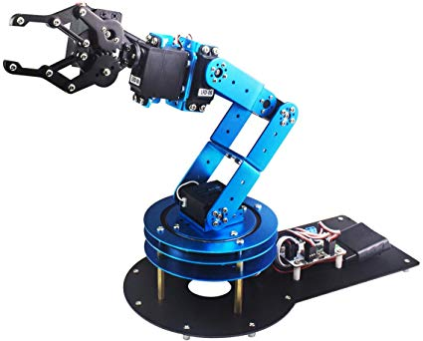

Figure : Robotic Arm

The microcontroller controls the robot by rotating each stepper motors connected to each joint. Unlike ordinary motors, stepper motors move in exact which allows it to move very precisely. The robot uses motion sensors to make sure it moves just the right amount, moving an end effector from a place to another. It is very important in the computer industry using microchips and other small electronics.

For our application, a simple 6 DOF robotic arm will require:

* 3x NEMA stepper motors: 2 to rotate the arm and forearm, 1 to move the end effector up and down
* Up to 4 Servo outputs (but just 2 units used to move the gripper)
* A 12V voltage controllable output (for a suction pump? electromagnet?)
* An input SENSOR (in the case we want to use an external button/switch/ Temperature sensor…
* i2C and UART communication ports (A LIDAR sensor can be connected to measure distances precisely)
* The **ESP8266** **Wi-Fi** module
* An Arduino microcontroller and/or a Raspberry Pi controller

The **ESP8266** **Wi-Fi** module will let you control the Robotic Arm from **any WIFI connected**device like a smartphone/ tablet or even a computer. It will create its **own network**.  **Alternatively**, you can control the Robotic arm with just a USB cable and a control app.

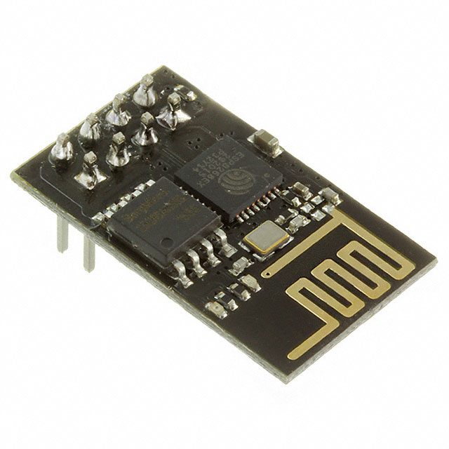

Figure 11:ESP8266 Wi-Fi module

Where it is recommended to have an Arduino Uno to interface with a raspberry pi for simpler applications. This can carry cones and cups and can fill up the cups and cones by moving the end effector to the desired position based on inverse dynamics/kinematics.

Figure : pros and cons for the robotic arm

### An autonomous ice-cream serving robot:

A robot that will oversee everything. Where the users choose the desired ice cream and then serve the scoops in a cup/cone. This type of robot requires man to work with already prepared ice cream and additives placed in tanks manually by the worker. Uses WIRELESS TECHNOLOGY (RF Technology) which is used to give the indication of the presence of the customer as well as the order received at the section is also done by making use of RF technology.

Figure : Pros and Cons of the autonomous ice-cream serving robot

Taking into consideration the following ideas we picked the conveyor belt for simplicity and accuracy. There is no perfect solution, however, according to our study the conveyor belt seems the best solution, its advantages surpass its disadvantages. A complex mechanical system, an odder control, and the cleaning are simply minor issues, not forgetting the total cost which is an important aspect for the manufacturer to take into consideration. If two machines produce the same result in a different way buyer will prefer the one with the least cost which is the case in our design.

## Dispensers

It is customized and designed to store foods in the best sanitary conditions, maintaining freshness and food quality. Furthermore, the dispenser is designed to be easily maintained and cleaned, as well as to dispose of dry foods efficiently without spilling and creating a mess, contributing to a clean work environment. In order to choose between the designs, we had to look for the most simple, cost-effective, and systematic option.

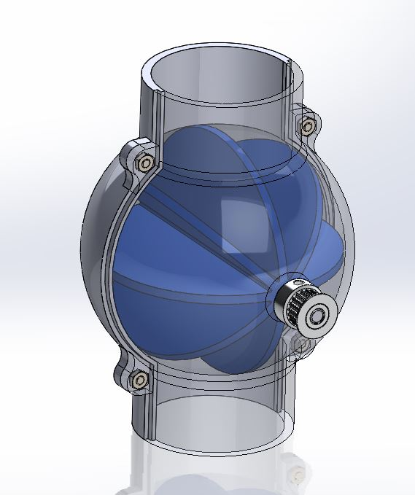

Figure : Dispenser design 1

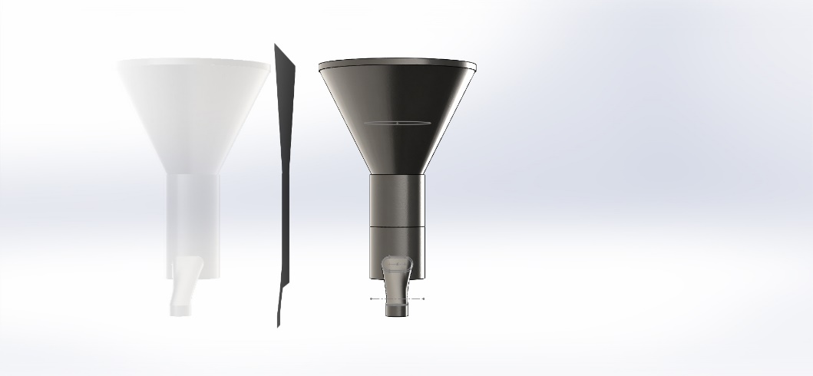

Figure : Dispenser design 2

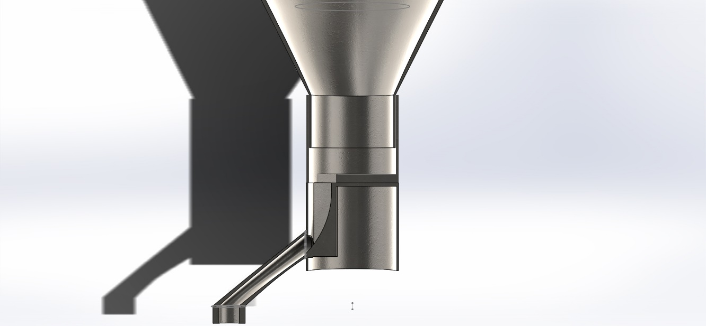

Figure Design 2

After comparing the designs provided above, we went for option two. In Design 2 not only we can handle the smart position control mechanism of the dispenser using the servo motor, but also it is user friendly and easy to build. Using SolidWorks we were able to draw the shape of our dispenser most optimally and efficiently.However, building the whole dispenser system we will need to have:

* Container that will store the topping we desire
* MG996 servo rotating the upper container
* Arduino or similar microcontroller with PWM support in order to control the MG996 servo (in this case we are using PIC)
* Ultrasonic Sensor
* Strain gauge

The setup is easy and consists of a microcontroller and a servo motor that will be mounted on the lower part of the dispenser. Instead of the switch , an ultrasonic sensor **HC-SR04** will be used for the triggering. The sensor will detect the cup as soon as it reaches the dispenser allowing the desired topping to drop on the ice cream. The main reason we are choosing the ultrasonic sensor because of its high frequency, high sensitivity and high penetrating power therefore it can easily detect the external or deep objects. These sensors have greater accuracy than other methods for measuring the thickness and depth of the parallel surface. This sensor will be controlled by the PIC controller.

## Features of the Ultrasonic Distance Sensor:

1. Supply voltage: 5V (DC).
2. Supply current: 15mA.
3. Modulation frequency: 40Hz.
4. Output: 0 – 5V (Output high when obstacle detected in range).
5. Beam Angle: Max 15 degrees.
6. Distance: 2cm – 400cm.
7. Accuracy: 0.3cm.
8. Communication: Positive TTL pulse.

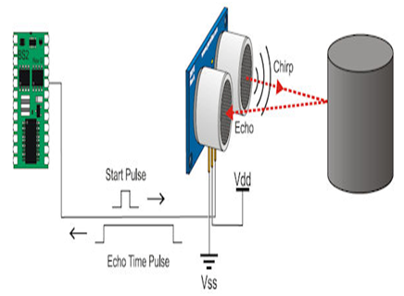

Figure Ultrasonic Sensor

The sensor detects objects by emitting a short ultrasonic burst and then listening for the eco. Under the control of a host microcontroller, the sensor emits a short 40 kHz explosion. This explosion ventures or travels through the air hits an article and after that bounces once again to the sensor. The sensor provides an output pulse to the host that will terminate when the echo is detected; hence the width of one pulse to the next is taken into the calculation by a program to provide results in a distance of the object.

Strain gauge load cell sensor will be used to convert force, pressure, tension, weight, into a change in electrical resistance which can then be measured, helping us to know the weight of each container respectively.  The conversion of load cell readings into useful total weight information requires several calculations based on the load cell's calibration specifications. The sensor will notify us when the container is empty, thus sending a message to the supplier in order to re-stack the toppings of each dispenser when in need.

*N.B. Load cells employ not just strain gauges but also a variety of other transduction techniques such as magnetostrictive, pneumatic, etc.*

We will need a Load cell amplifier which is a 24-bit analog-to-digital converter (ADC) designed for weighing scales and industrial control applications to interface directly with a bridge sensor. Or we can use calculations by referring to the datasheet of the load cell to calculate the voltage output in Kg or Lbs.

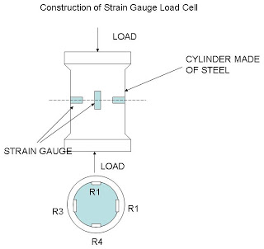

Figure Strain Gauge load Cell

The main parts of the strain gauge load cell are as follows. They are a cylinder made up of steel on which four identical strain gauge are mounted and out of four strain gauges, two of them (R1 and R4) are mounted along the direction of the applied load(vertical gauges). The other two strain gauges (R2 and R3 Horizontal gauges) are mounted circumferentially at right angles to gauges R1 and R4.

A good way of turning these small changes into something more measurable is to interconnect them as a Wheatstone bridge.

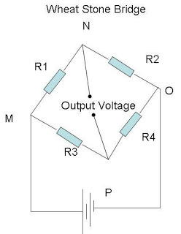  VO = [       R3       -        R2      ] x P  
 (R3+R4)       (R1+R2)

Figure Wheat Stone Bridge

## Operation of strain gauge Load cell

### Let study the operation in two cases

#### Case 1

When there is no load (force) on the steel cylinder, all four gauges will have the same resistance. As the terminals N and P are at the same potential, the wheat stone bridge is balanced and hence the output voltage will be zero.

#### Case 2

Now the load (force) to be measured (say compression force) is applied on the steel cylinder. Due to this, the vertical gauges R1 and R4 will undergo compression, and hence there will be a decrease in resistance. At the same time, the horizontal gauges R2 and R3 will undergo tension and there will be an increase in resistance. Thus when strained, the resistance of the various gauges changes.

**Advantages of Semiconductor Strain gauges**

* Most sensitive.
* Very cheap.
* Strong output signal (high GF)
* No creep (no bonding)

## Interface

To control our machine we will be using a touchscreen placed on the front where all options will be displayed to the user. To create this interface with the user two options arose, first using a raspberry pi with its custom made 7-inch touch-screen or using an Arduino with a touch-screen built for it or any android touch-screen and connecting them over a USB serial connection.

### Raspberry pi

Creating an interface with the raspberry pi requires the use of the python language. Although there exist multiple different ways of creating GUIs (Graphical User Interface) with python the most common technique is using the Tkinter toolkit. Python with Tkinter is the easiest and fastest way to develop a GUI application. The Tkinter library was made so that anyone could be able to create a personalized interface. The library is so large that a lot of options are made available such as multiple types of inputs from the user (button, checkbox, graphical slider, text input...) furthermore; all of these can be tuned in length, width, font of the writing, color of the writing, active background and so many more options. Finally, Tkinter offers access to three different geometry managers, making it easy to organize the widgets on the interface.

### Arduino

Creating an interface with an Arduino may be done in two different manners. First, if we were to use a screen designed for the Arduino then the language to be used would be C++ where so many methods to develop GUIs are made available. One of the easiest ways to create an interface with the Arduino is using the MegunoLink Pro's very user-friendly user interface. Unfortunately due to the user-friendliness, the developer can no longer create unique interfaces. Now on the other hand if the screen used is an android touch-screen then to create the interface android studio would be used and then the info communicated to the Arduino through a USB serial connection. The android studio uses java language and offers millions of possibilities to the developer and this is proved by the millions of applications available on the Google Play Store.

Now although a choice could already be done between the two options depending on preference in language between Python, C++, and Java. In our case, multiple other factors that we'll be discussing later will come into play as deciding factors.

## Scanning Barcode

To recreate a monetary kind of system to use our vending machine, as we cannot install a credit card reader. We will place a barcode reader and create a database where each barcode will have a predefined amount of money stored. Depending on the amount of money stored and the price of the cup ordered, the transaction should either be accepted or rejected.

To create a Barcode scanner two options are considerable, using an actual barcode scanner or using a camera to detect and read the barcode.

### Barcode scanner

First, we have to make sure that the barcode scanner has a USB serial connection. Then we start to configure our controller and set up the serial interface. Then all that is left to do is to interpret the reading of the barcode scanner. Reading directly from the output of the scanner will not be helpful as it needs some converting to get the barcode number correctly. All of the conversions can be found online and brought into the code directly.

### Camera

Using a camera and OpenCV will facilitate a lot in the process of reading barcodes or eventually QR codes. Once the image is scanned and the barcode recognized using the functions of OpenCV to delimit the barcode, we can use different kinds of libraries depending on the language we are using to decrypt the barcode. For example in the case where Python is the language used then we pass it to a dedicated Python barcode decoding library such as a Zbar.

Although both options of the barcode scanner work on a raspberry pi and both produce the same result, both options for the barcode scanner are favored to use with the raspberry pi, the barcode scanner due to the availability of a USB port and using a camera with OpenCV on the raspberry pi is so much easier. All in all most of the factors were pointing towards using the raspberry pi such as availability of the touchscreen in the local market or preference towards python language rather than C++, and the barcode scanner machine requires the client to scan his card on his own, so we would rather have the camera installed.

## Controllers

In our project two controllers will be used, a raspberry pi 3 B+ and a PIC16F887 which will of course be communicating to run the automated yogurt machine. The communication between the raspberry pi and the pic will be done serially using the UART protocol at a baud rate of 9600 bits/s with an eight-bit communication. The connection between both controllers will be made through the Tx and Rx pins of both devices (Tx pin of the pi will be connected to the Rx pin of the pic and vice versa). Finally, the communication will be made by sending flags from one device to the other which we will later encode, as an example if the pic receives a ‘B’ from the pi then it should launch the command that would have been pre-stored as a B.

### Raspberry pi 3 B+

The raspberry pi in this project will be taking care of the interaction with the client through the interface to take the orders and deliver them to the pic, but also the pi will be the one handling the business side as it will be made as a ‘credit card’ reader. The raspberry pi will be controlling a camera that will be scanning a card with a barcode on to check the amount of money stored in that account to see if the order can be placed. A flowchart will be shown and explained here below.

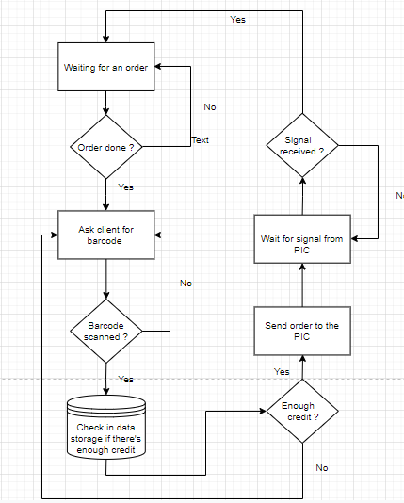

Figure : Raspberry pi code flowchart

The raspberry pi should wait for the user to come and order through the touch screen interface, once the order did it should ask the client to scan his card and check if the card in question possesses enough credit if it doesn’t then the screen should indicate so and ask the client to scan his card again. Now once the card is accepted the pi should then send out the order to the pic and then wait to receive a signal from the pic before returning to taking orders.

### PIC16F887

The PIC on the other hand will be controlling all the circuitry and movement of the frozen yogurt machine. Hence controlling all servos of the dispensers and controlling the motor to advance the belt, also it will be reading values from the ultrasonic to know when to stop the belt, and in the meantime reading values from the load-cells to check if the dispensers are empty.

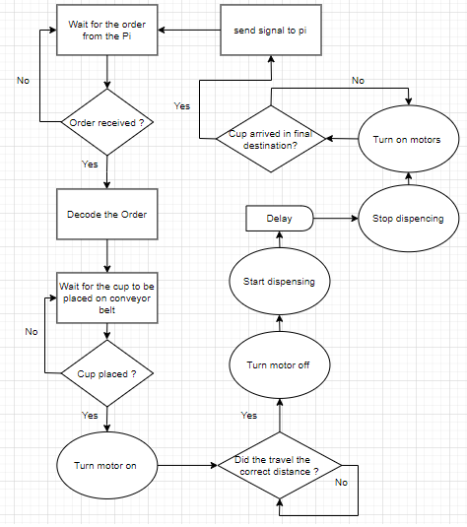

Figure : PIC code flowchart

The Pic should wait for the order from the pi; once it gets the order it should decrypt the message and wait for the customer to place the cup on the conveyor. If the cup is placed on the conveyor belt then the motor should turn on to rotate the belt and advance the cup, once the traveled distance is covered the motor stops, and the dispenser discharge into the cup stops and then the motor turns on back again. The distances to be traveled and dispensers that should discharge will be known through the decryption of the signal sent by the Pi. After the last discharge, the motor will be turned on until the final destination of the cup will be detected, then the motor turns off and the pic sends a signal to the Pi and goes back to waiting for another order.

# Results

Once all of the possible solutions were well studied and researched, and the actual path we were going to work on was chosen we decided that we were going to design the whole project on Solidwork to help us visualize better the end product. Also as most of the parts were going to be manufactured by it was an additional help. Here below you can see some snapshots of the final result we got on the software.

## SolidWorks Design

## 

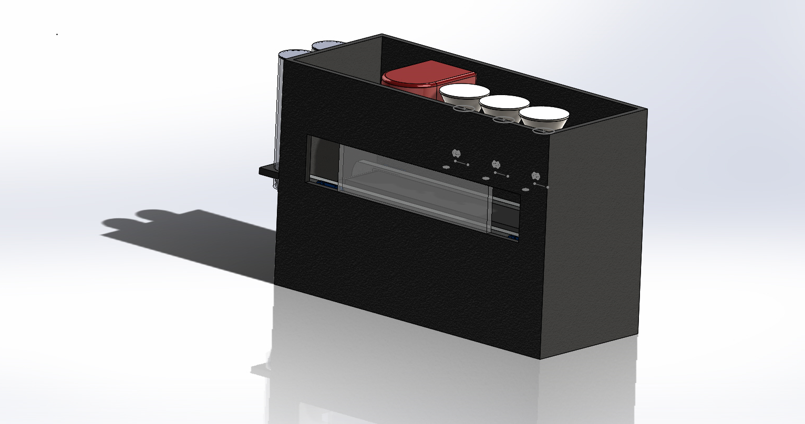

Figure : Vending machine viewed from the top right

In the picture above we can see the idea behind our vending machine with openings on both sides of the machine. The left opening is there so that the customer can take a cup and place it on the conveyor belt so that his order can be taken and the right opening is there so that the customer can take back his cup once finished. The glass in the middle is here to protect the dispensers. First of all, for hygiene rules, the tip of the dispensers should remain clean at all times. But also the cup should keep its path and not be disturbed by any outdoor factor and is hence protected by the glass.

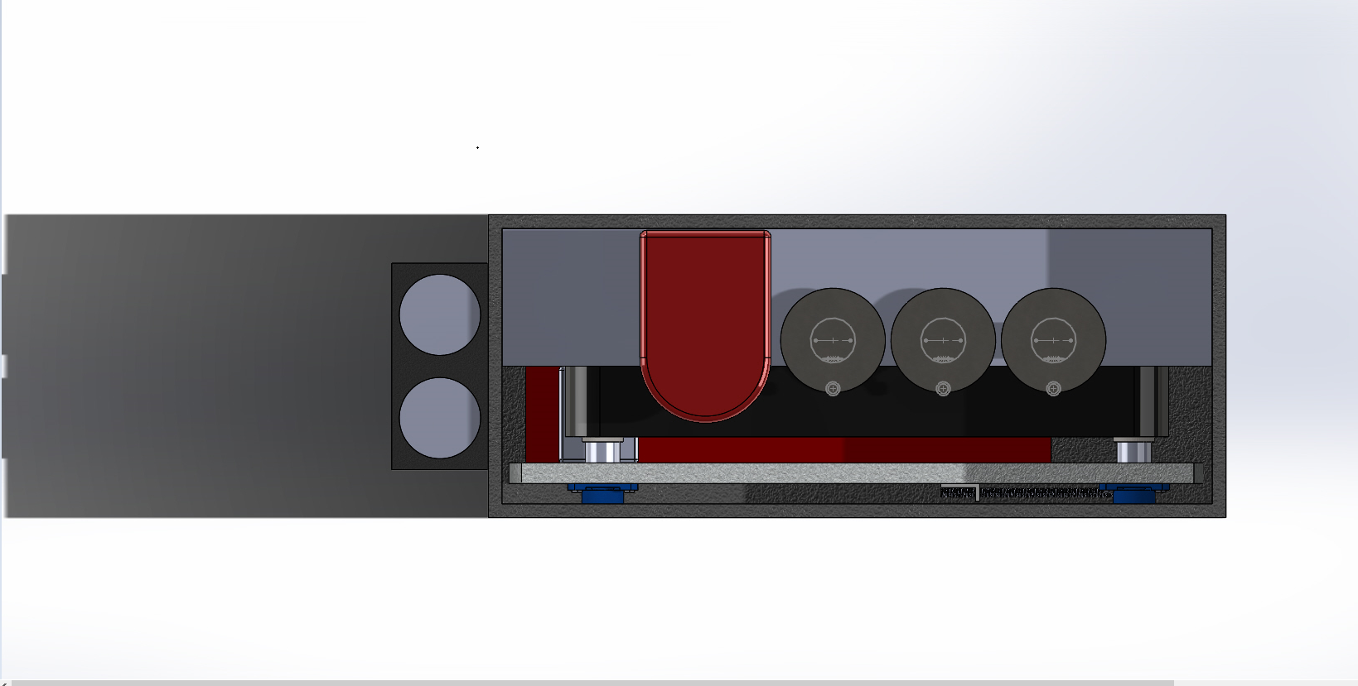

Figure : Vending machine viewed from the top

In the picture above we can see how the automated frozen yogurt dispenser works inside the box. On the left, we placed two cup dispensers to represent two sizes (small and large) as we hope to be able to offer two different serving sizes. Now inside on the floor of the box, we placed our conveyor belt mechanism which will be in charge of the displacement of the cup from one dispenser to another until it reaches its final destination where the customer should reach in and take the cup. Above the conveyor belt, we placed a shelf where all the dispensers will be placed to be able to dispense into the cup. On the shelf, we can see a red dispenser representing the frozen yogurt dispenser followed by three dispensers each containing different ingredients to maximize the customer’s choice.

# Implementation

## Dispenser

After comparing the options we had at hand regarding the dispensers, we decided to go with option two, hence it perfectly matches what we need. Now in order to start the manufacturing part we had to allocate our resources. At first, we got two Nido Stainless Steel containers of height 12cm and a radius of 5cm. They were mounted on each other via servo MG995 servo motor. The servo motor was controlled using the PIC, which enables the rotation of the upper container allowing it to dispense the topping that was introduced in it. Secondly, we bought the Ariete dispenser which is a Softy Ice-Cream maker. A new compact machine for making soft ice-cream. Easy to use, it makes soft and creamy ice cream in any flavor in just half an hour. Disassembles easily for simple cleaning and saves space thanks to a special closing system for when it is not in use.

Product Specification

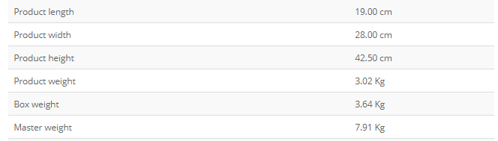

Figure Ariete Specification

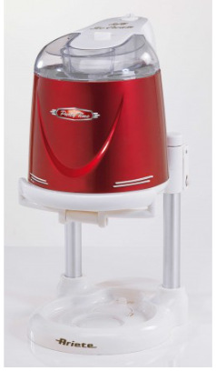 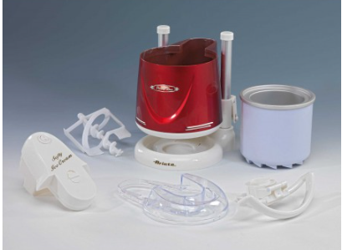

The above figures represent the Ariete dispenser we’re talking about and the components that come with it after purchasing it. The MSRP for this specific product is 80 U.S dollars only.

Now in order to control the movement of the ice cream we used a DF15SR servo motor. To make the spilling stop we taped a water cap on the edge of the servo.

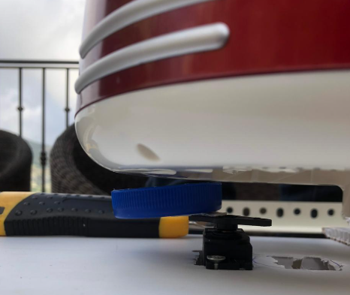 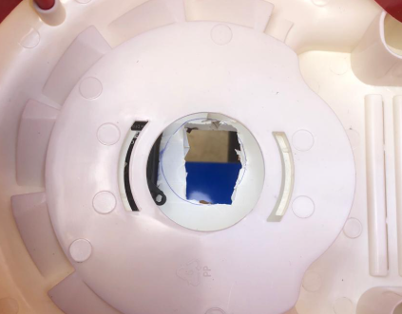

Figure Ariete with servo Figure Top view of Ariettes servo

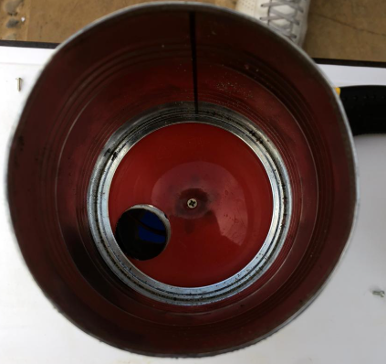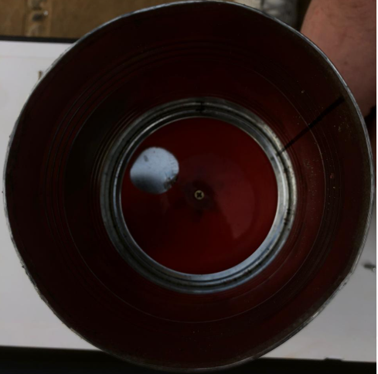

Figure Container opened Figure Container Closed

We can see the two different positions of the topping dispenser, which is being controlled by the servo motor.

Now in order to mount the topping dispenser and the ice cream maker on the same level and place them above the belt. We had to implement a standalone system that holds them. In order to do so, we had to fabricate a table shape system made of steel. The materials used in this operation were the following:

* Steel Cutter
* Aluminum Stainless Steel
* Meter
* Bolts and Joints

First of all, we had to take measurements of the belt mechanism in order to cut the steel accordingly, so that it perfectly fits above it.

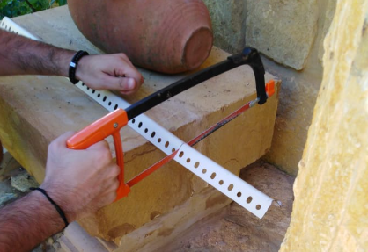

Figure Cutting steel

We can see that we had to manually cut the steel in order to fabricate the table we need. After cutting all the parts we need. The parts were assembled using bolts and joints.

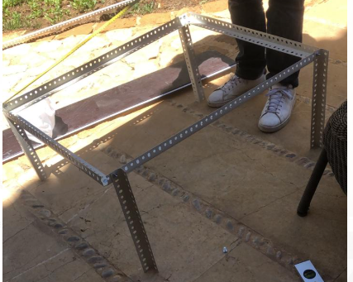 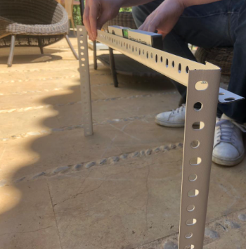

Figure Assembly

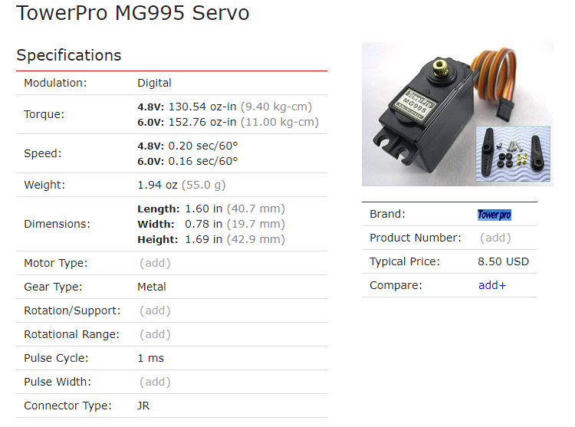

Figure MG995 servo

To control the servo mounted on the dispensers we used the following code that was initialized on MplabX

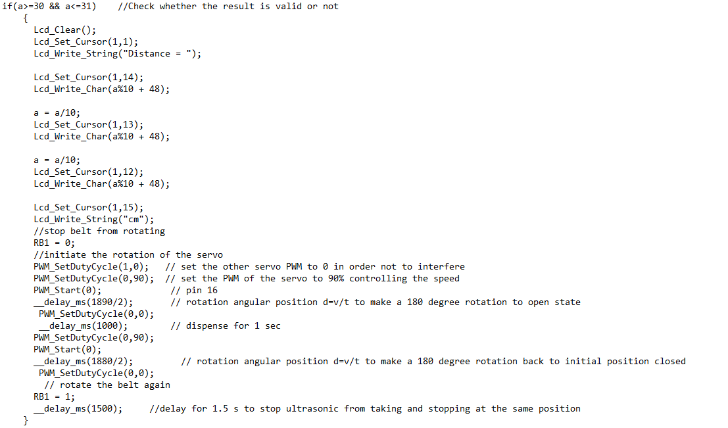

Figure control ice cream maker

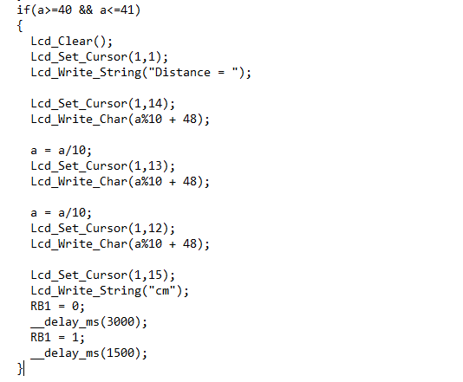

Figure control topping dispenser

## LCD

To visualize the output of the pic so we don’t have to keep it connected to the PICKkit we used a 16×2 LCD screen module ADM1602K. The LCD was connected to the PIC by pins 21,22, 27, 28, 29, 30 using the D class pins of the PIC which are set as outputs The by the commend: TRISD = 0x00; the following diagram will visualize the set up of the LCD:

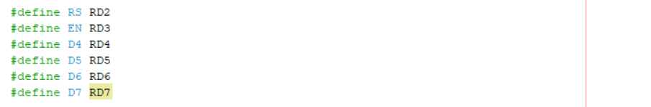

Figure 32: Output pins of the LCD

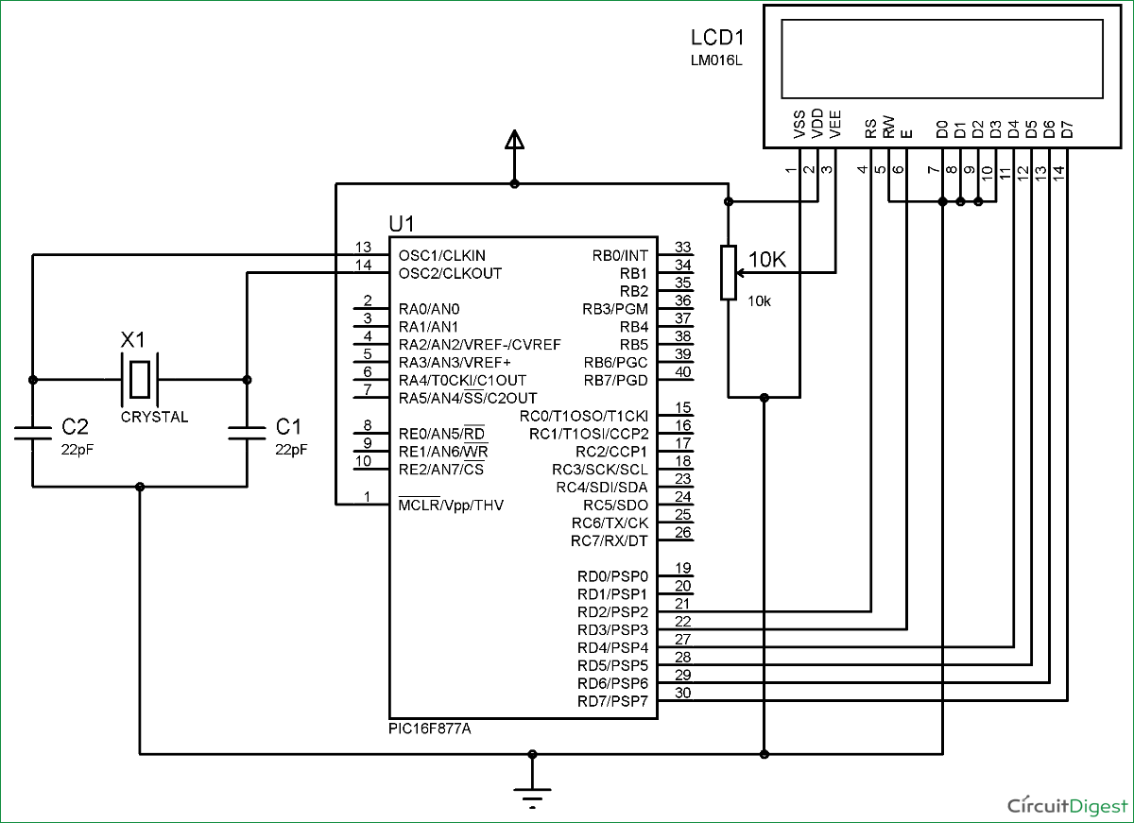

Figure 33: LCD connection

A potentiometer was used to calibrate the brightness of the LCD screen and the connection was based on an 8-bit configuration. To use an LCD it s position and bits should be initialized and the cursor should be updated in each typing, that’s why an Lcd_Init() and Lcd_Set_Cursor were written at the beginning of the code. The functions of the LCD were inherited from the LCD header class.

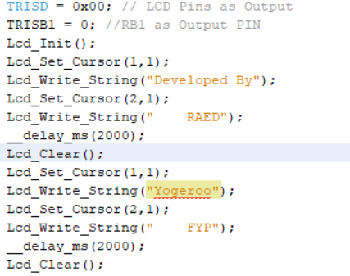

Figure 4: LCD typical code

## Ultrasonic

An HC-SR04ultrasonic Sensor to track the cup position on the belt was used. We set 3 positions for the ultrasonic to keep track of them and be able to stop the belt and operate. The first distance was for the frozen yogurt dispenser, the second distance for the topping and the last one for the user to take out the cup after finalizing it. The stopping positions were given a 2 cm tolerance to make sure the sensor won't missing any stopping point and to make sure the belt runs after a stop and delay of 1.5 s was given for the system to hold the sensor from operating in the stopping positions. The 1.5s second delay was long enough for the belts to surpass the stopping position as the Belts is running at a 5.9 cm/s speed. The ultrasonic used was more reliable than the IR sensor due to many circumstances and it was ideal for our design. The sensor generates a signal every 10 µs from pin 33(RB0) of the PIC and received at pin 37(RB4) of the PIC. The code of the ultrasonic was also calibrated to give us a human-friendly distance in cm:

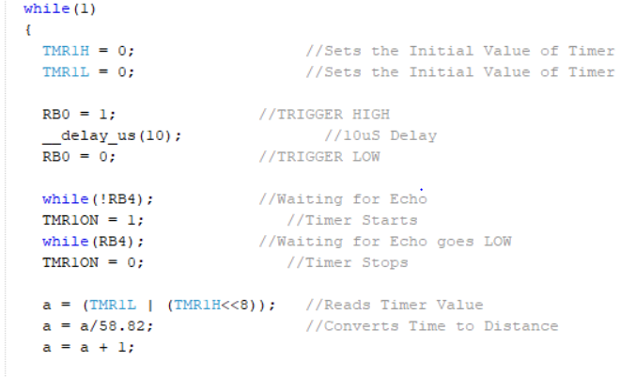

Figure 35: Ultrasonic code

The following dummy variable “a” was the one linked with LCD to make the reading of the sensor trackable.

## Relay

The connection between the 12 v motor and the PIC was only possible using an electromechanical switch (relay). For our design, we used an SRD-05VDC-SL-C 2-Channel 5V Relay Module. Whenever the ultrasonic sensor detects a stopping position, it will send a signal to the relay through pin 34 (RB1) which was set as an output pin by TRISB1 = 0; to switch and open the connection between the battery and the motor. The following figure will illustrate the connection of the relay:

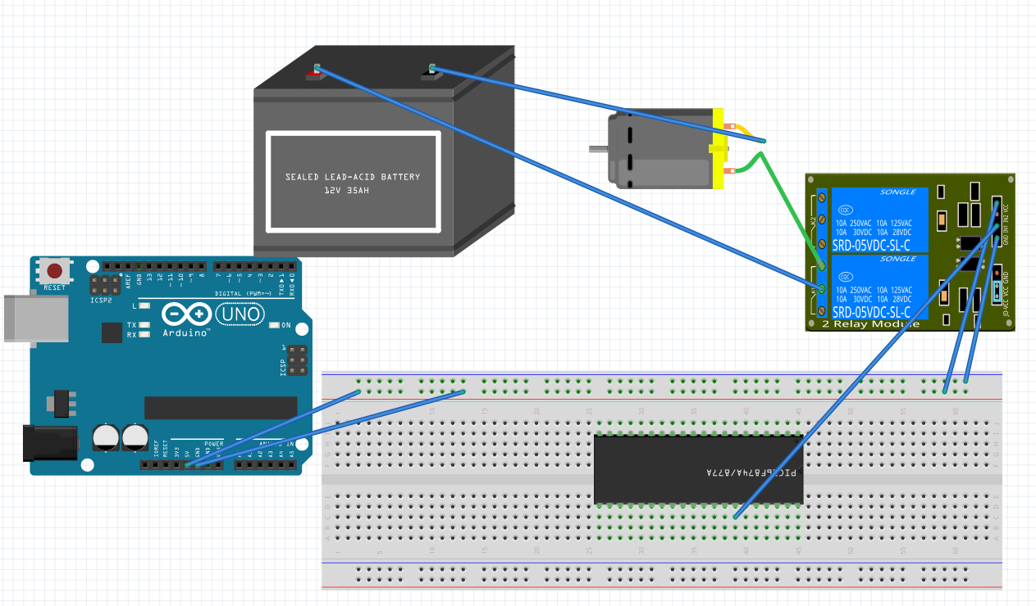

Figure 36: Relay connection

## PIC

The implantation of the project was based on the PIC16F877a microcontroller. The signal received from the Raspberry Pi will be processed and sent to the PIC which in return will set up the sensors and actuators according to the signal. The PIC will be acting as an input to the signal received from the PI and output to the sensors and actuator. The following diagram will illustrate the role of the PIC microcontroller for our design:

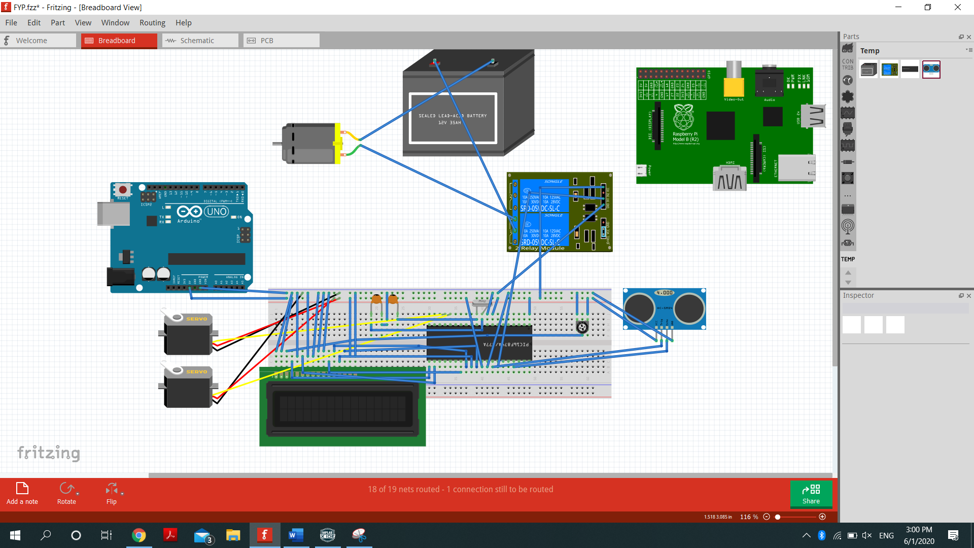

Figure 37: full hardware implementation

We used fritzing to model the whole design including every component on the breadboard, creating a virtual reality design. We also used fritzing to show the connection and the schematic of the project:

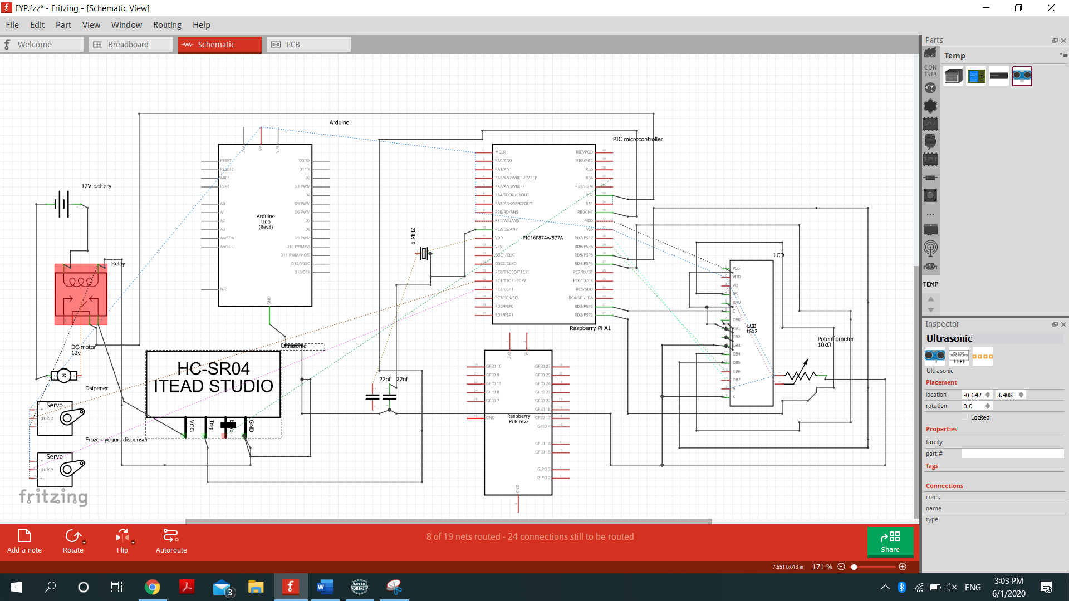

Figure 38: Schematic

To make the system comprehensible we also modeled the behavior of the system using a block diagram implementation. The process of the system after receiving the signal from the Pi will react by the following figure:

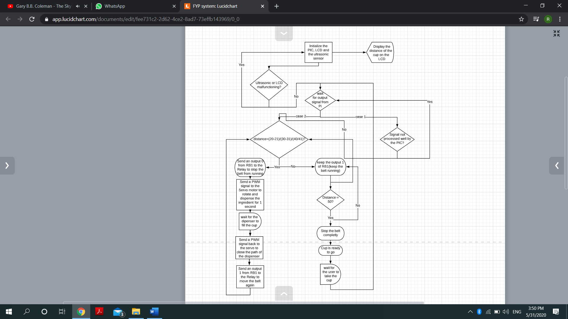

Figure 39: PIC block diagram procedure

The choice of the PIC was based on the simplicity and the needs of our project. This PIC was set up with an 8 MHZ external oscillator as the 20 MHZ internal oscillator was not very accurate and very fast. The speed was based on the specs of the PIC, which initiate an instruction every 4 clock cycles with each clock cycle: $\frac{1}{freq}$ so in total an instruction every 0.5 µs.

Moreover, we used MPLABX IDE/IPE for coding and debugging. Mainly MPLABX IDE was used to coding in C language (XC8 2.10) and configuring the PIC Bits and the MPLABX IPE was used for debugging using a PICkit 3 in addition to its PIC seat.

Configuration Bits:

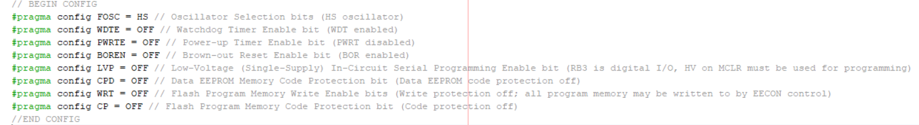

Figure 40: PIC bits configurations

In addition to the configuration of the bits, the frequency (external) was set to 8 MHZ by connecting a Crystal Ocsiallator with its 2 sides connected to two 22 nF capacitors on its OSC1 AND OSC2 (pins 13/14).

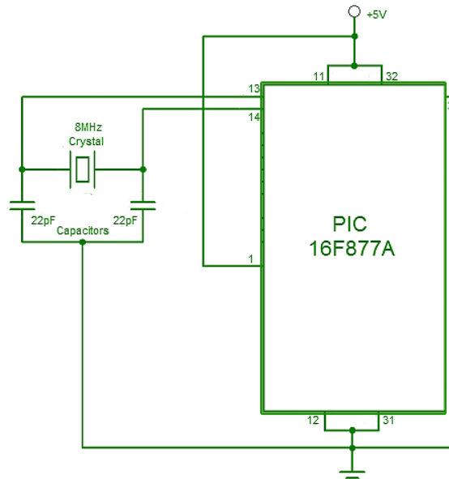

Figure 41: External clock set up

## Code

The code was based on stopping position each stop position involves a servo, the ultrasonic, LCD, and the Relay. The following code will explain each part of the code and how it affected the code:

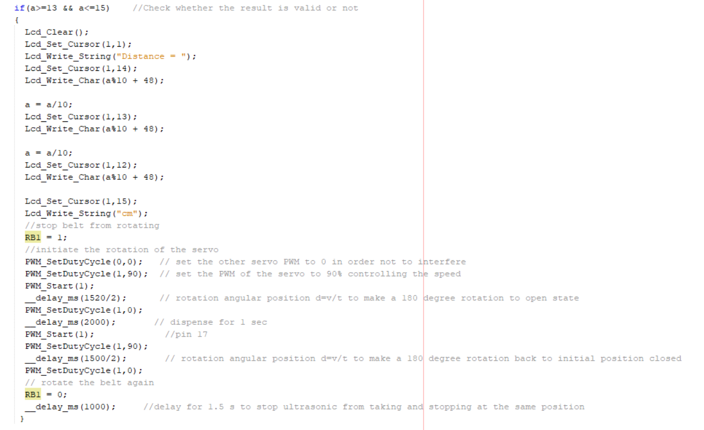

Figure 42: Code of the first stop of the frozen yogurt machine

It involves everything related to the PiC including the LCD commends and the display part and delays the dispensing for 2 seconds because frozen liquids need more time to dispense

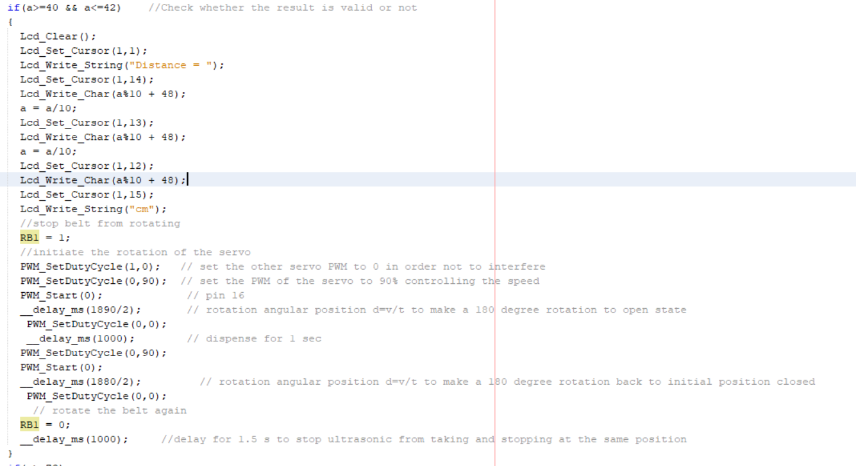

Figure 43: Code of the second stop of the toppings

It involves everything related to the PIC including the LCD commends and the display part and delays the dispensing for 1 second because frozen liquids need less time to drop the toppings. Overall, the stopping sites were very accurate, and the cup included the required commends as given by the pi to give a reliable system.

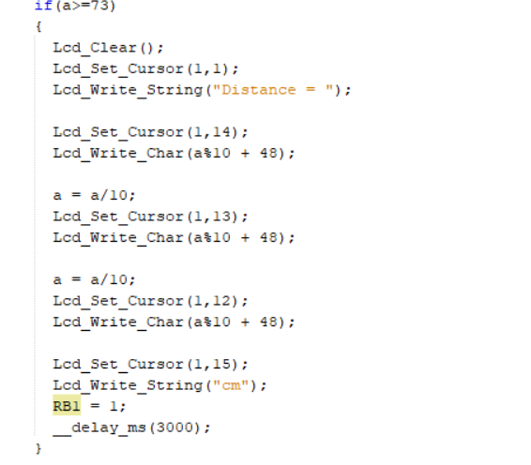

Figure 44: stopping the loop

So before placing the cup to save energy and consume less power this loop will signal the belt not to run unless the cup is placed after the communication. This loop also gives a commend to the cup to stop at the end of the belt for the user to lift it and enjoy it.

## Conveyor belt

Speed = $\frac{D x rpmx .2618 x 1.021 x \frac{1}{5}}{196.85}$

**D**: Diameter of the drive pulley (inches)

Dividing by 196.85 to convert from feet/min to m/sec

The design of the conveyor belt turns out to give a speed of 5.9cm/s or 212.4m/h due to the gear reduction. The reduction translated to a $\frac{1}{5}$ reduction of the motor speed due to the gear teeth meshing, calculated by this equation:

The Belt was made of 2mm sickness PVC and could withstand a tension of 12 kg at ideal tension. The total length of the belts is 180 cm making a:

L=(D+d) /2+2C

**C**: Center to center distance

**d**: Diameter of tail pulley

which in this case the tail pulley is equal to the drive pulley which is 6cm which implies that the length of the belt on each side: Center to center distance=87 cm length on each side which implies an 87 cm available space for the cup to move in.

The design of the belts was in a scalable way to increase or decrease the tension in the belt in case of static stress problems. 2 ball bearing blocks were positions at each side of the belt to keep the pulley steady and free to rotate with minimal friction and tension.

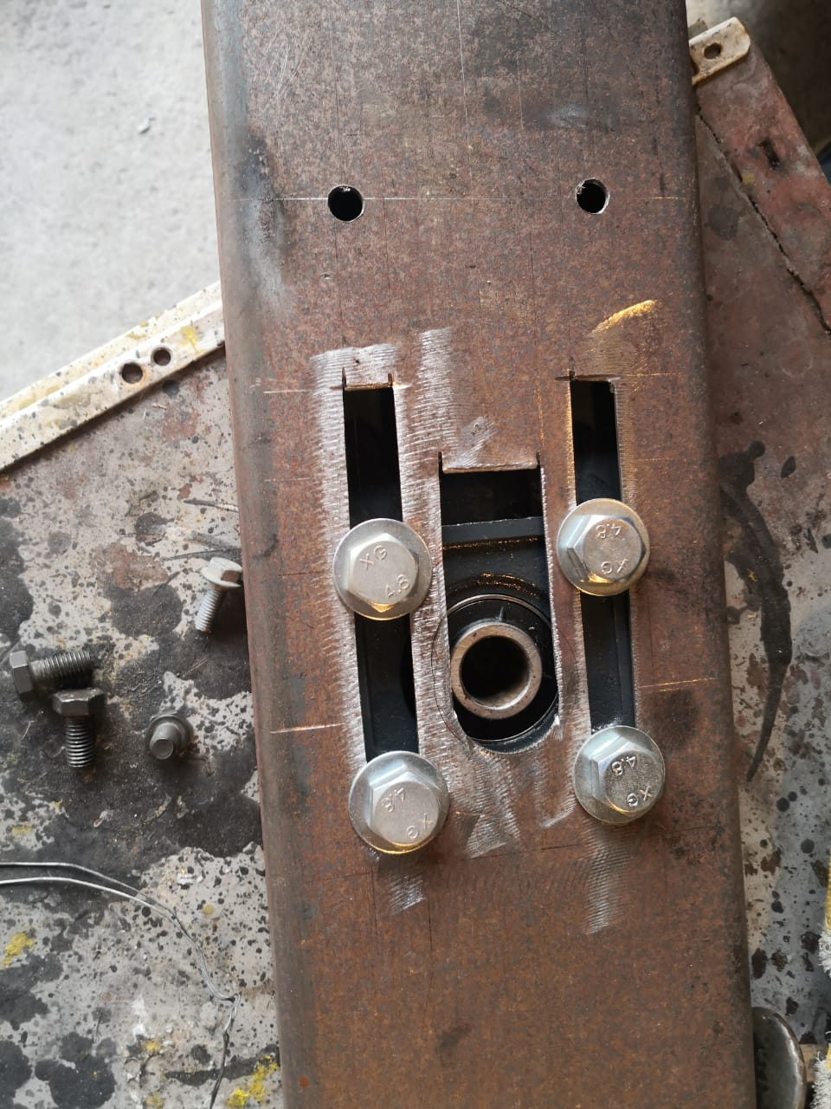

Figure 45: Scalable pulley position

The conveyor weights around 18 kg and height around 0.3m which is a table positioned conveyor. The conveyor was also painted to prevent rust and to make it presentable:

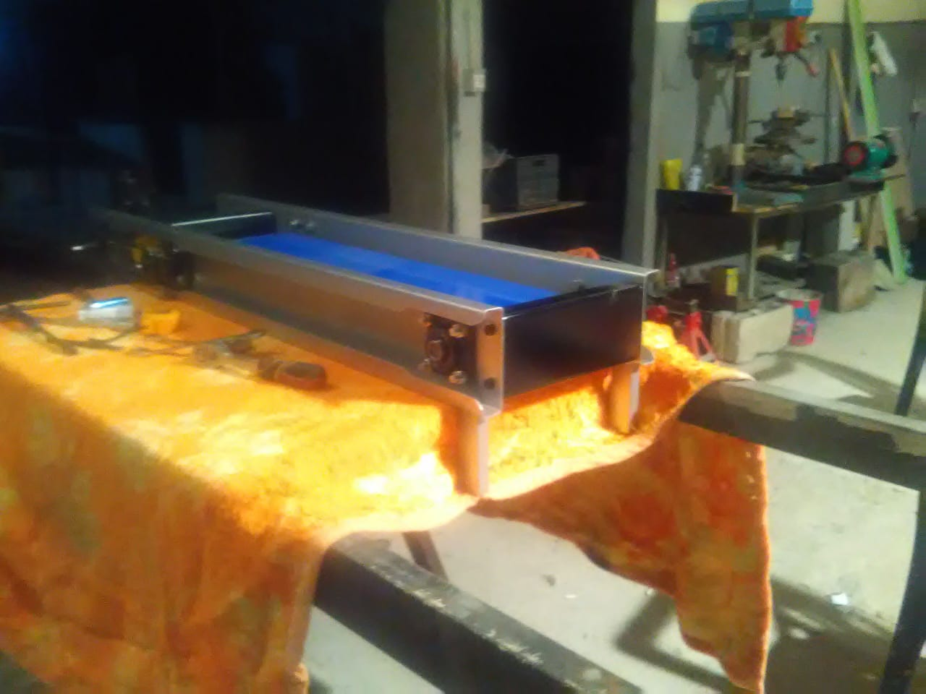

Figure 46: Conveyor Belt painting

The final design of the Conveyor belt made it reliable and ideal for our system. The gear and chain system used to rotate the system are hidden by the black steel plate for safety purposes, and in order to interfere with any component:

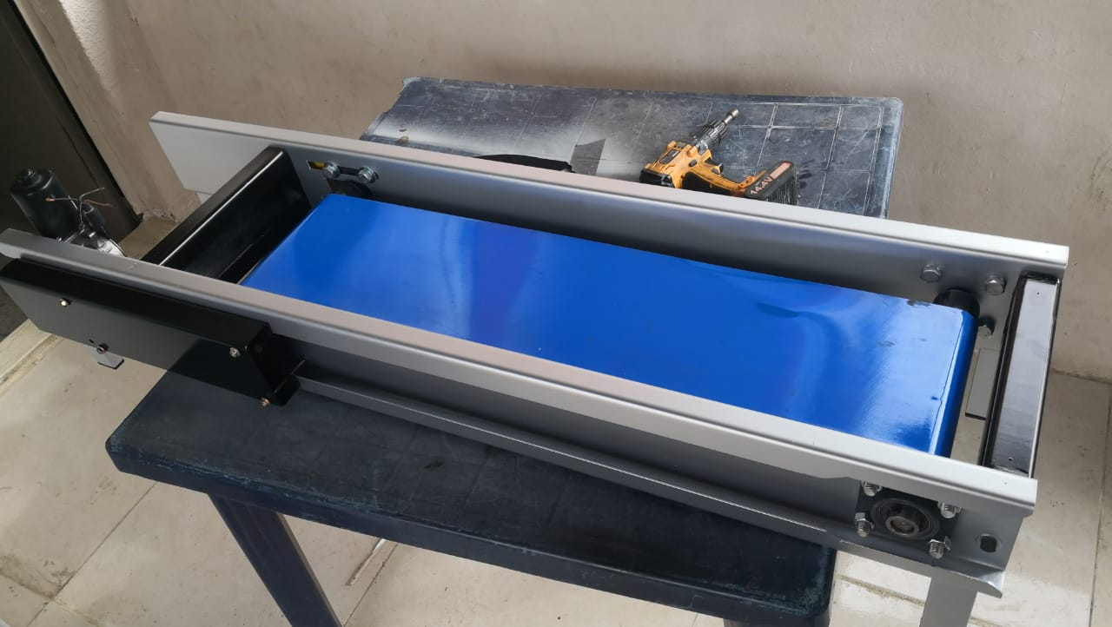

Figure 47: Conveyor Belt final design

## Interface

In our case, we decided to work with a raspberry pi to create the interface and combining it with a barcode scanner to recreate the credit card system. The interface was built using the Tkinter library for its simplicity.

The main page of the interface is the welcoming or waiting page before a client comes and decides to order.

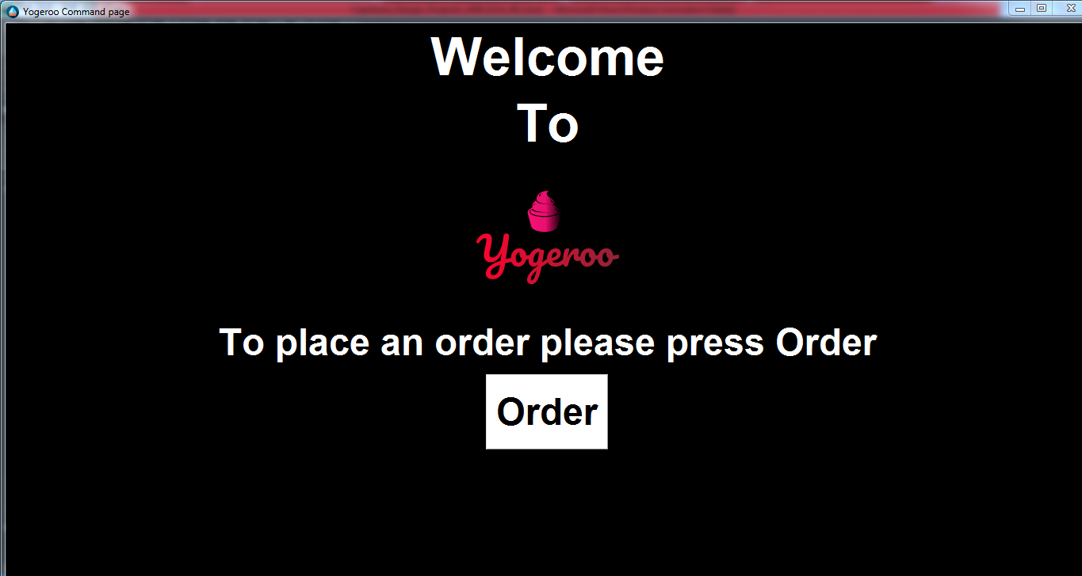

Figure 48: Interface the main page

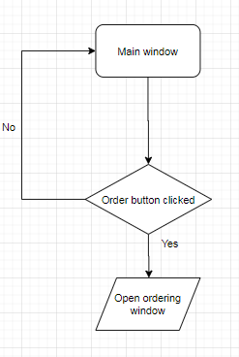

Figure 49: Flowchart explaining how the main window act

As we can see it is a very simple first page with small details such as an icon on the left corner of the page that will be added to each single window. And only one button that will open the second window.

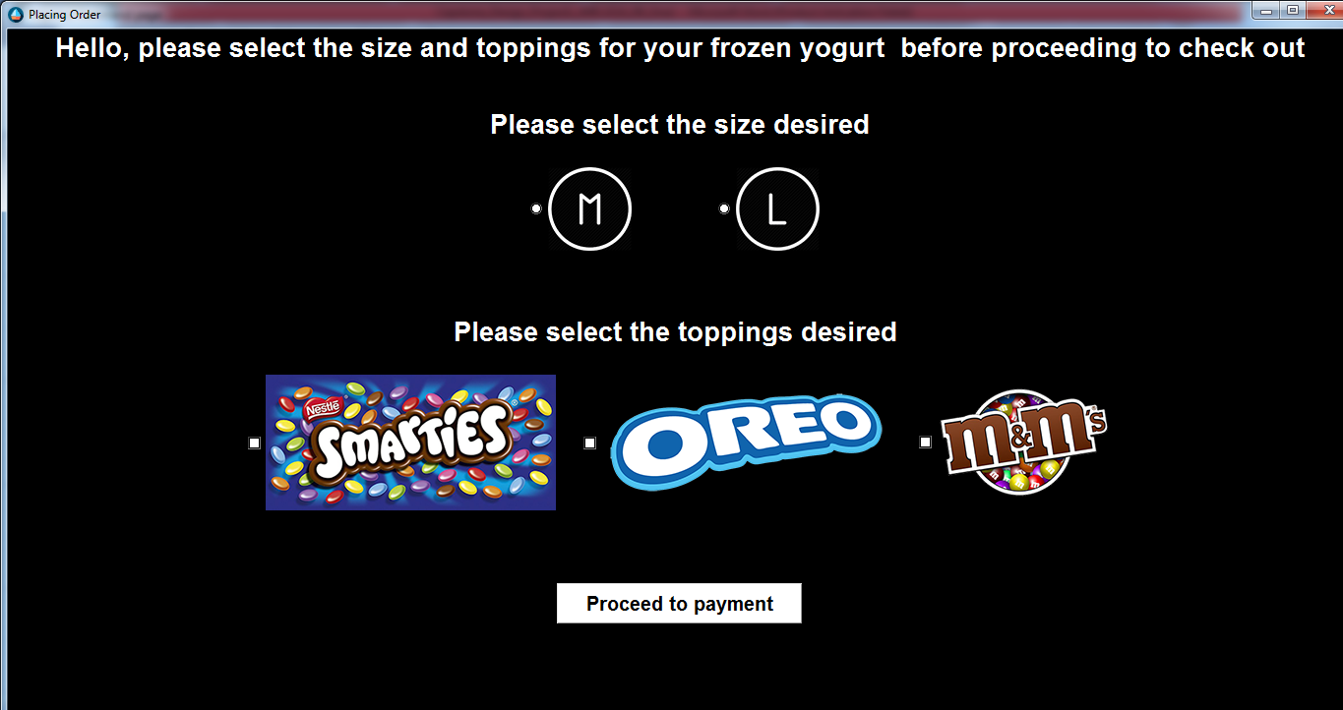

Figure 50: Ordering window.

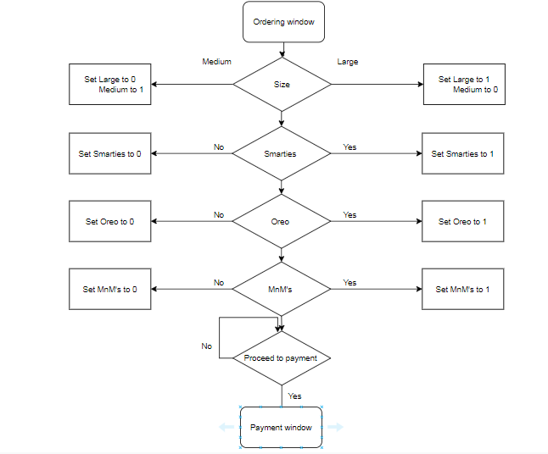

Figure 51: Flowchart of the ordering window.

In the second window, the user selects the size of the cup he wants and the toppings he would like to add to it and based on the buttons he clicks variables created in the code will be set either to 0 or 1 and that’s how we will be keeping track of what the order is. Once the client has decided what his order will be and click the proceed to payment button to open the third window “payment “ window in which the user will get the price of the cup he ordered and in which he will have to scan his credit card, then decide if he wants to confirm the order or cancel it.

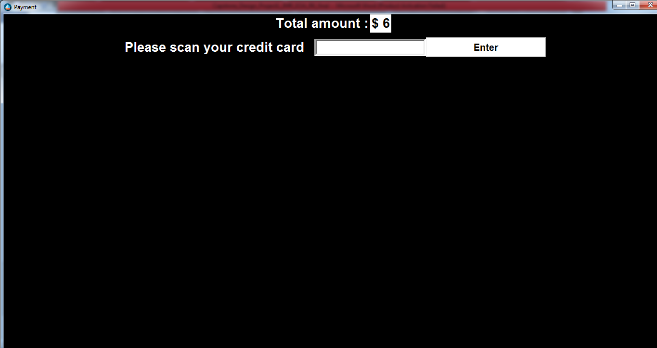

Figure 52: Payment window before scanning the credit card.

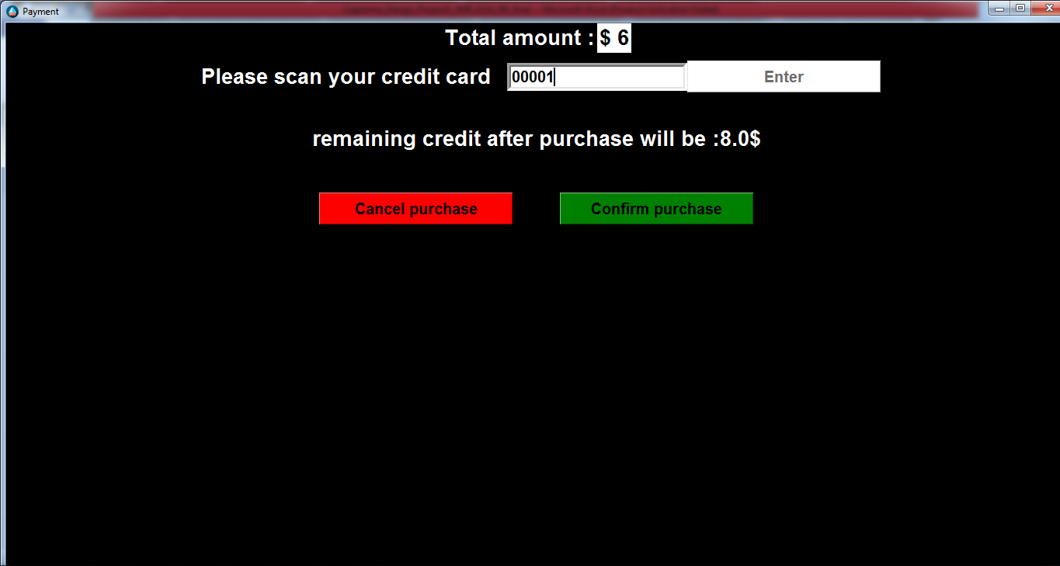

Figure 53: Payment window after scanning the credit card if there’s enough credit.

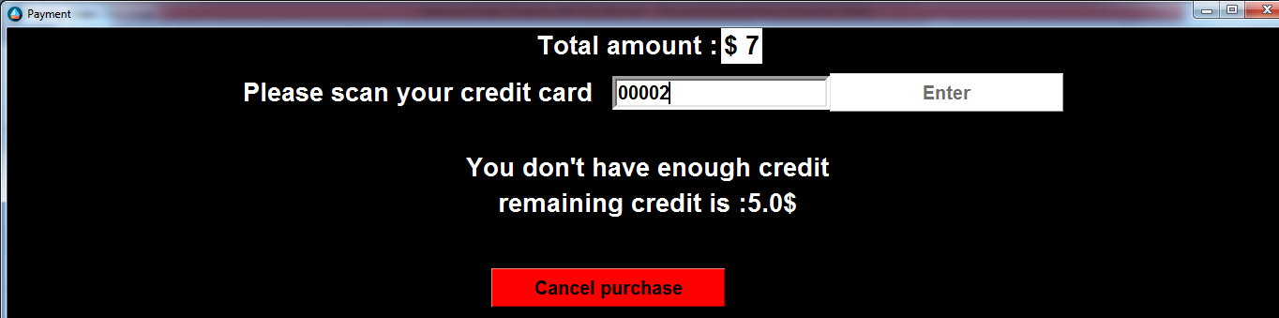

Figure 54: Payment window after scanning the credit card but there isn' enough money remaining.

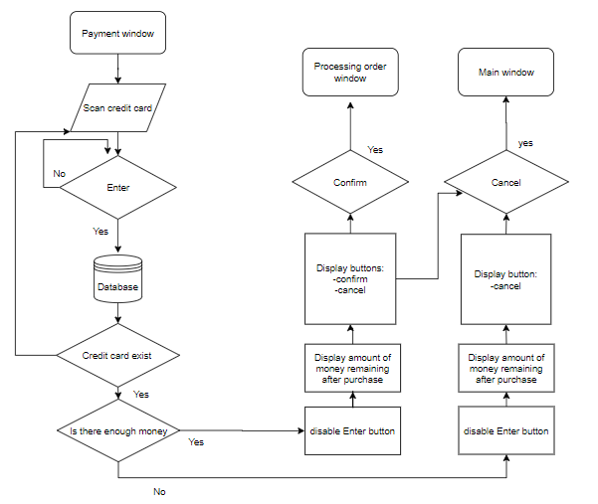

Figure 55: Payment window flow chart.

In this window, the client scans his credit card using the barcode scanner, if there’s enough credit the remaining money after purchase will be displayed with two buttons, confirm and cancel, the confirm button will take you to the processing order window and cancel will take you back to the main window. If there isn’t enough money, the remaining credit will be displayed and only the cancel button will be displayed.

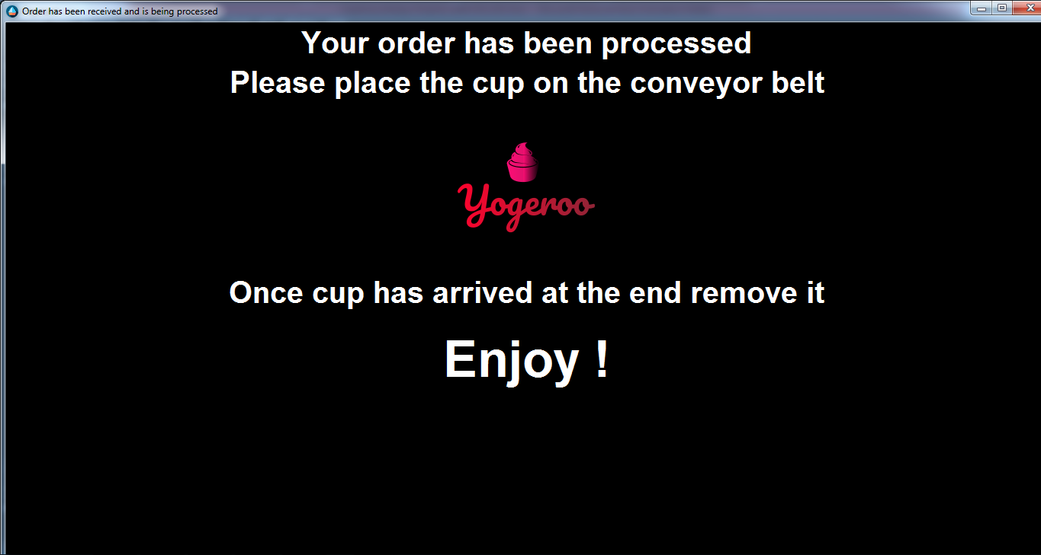

Figure 56: Processing order window.

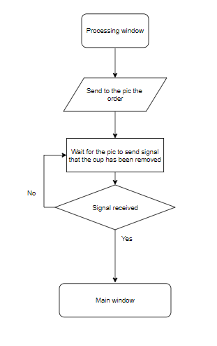

Figure 57: Flow chart of the processing window

In the final window of the interface, the raspberry pi sends the order to the pic and waits for the pic to send back a signal meaning that the cup has been delivered to the client so the interface goes back to the initial page.

To read the barcode, we were planning on using a camera with an open CV but it turned out that using a simple barcode scanner is way easier as once it is plugged to the raspberry pi it is considered to be a keyboard. So we opted to use a barcode scanner and printed three different barcodes representing our 3 different clients and included them into our database and assigned money to each client randomly.

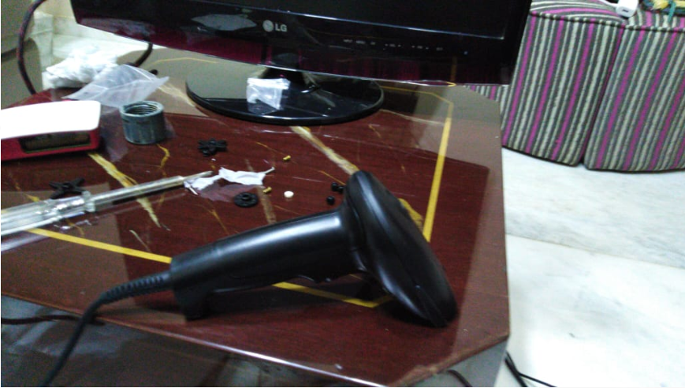

Figure 58: Barcode scanner used

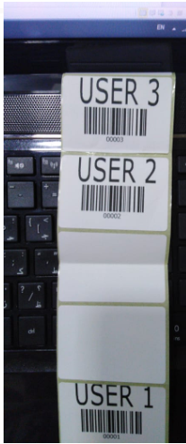

Figure 59: barcodes used to represent 3 users

## Pricing

|  |  |
| --- | --- |
| Component | Price in L.L |
| Belt Mechanism | 280,000 |
| Ice Cream Maker | 120,000 |
| Topping Dispenser | 20,000 |
| Servo Motors / Piece | 20,000 |
| Barcode Reader | 60,000 |
| Aluminum Stainless Steel | 50,000 |
| Electric Components | 150,000 |
| Bolts and Joints | 5,000 |
| Printing Labels | 1,500 |
|  |  |
| Total | 706,500 |

Table : total pricing

The above table represents the actual cost of our frozen yogurt vending machine. We had to cut out some unnecessary components to stay within our budget.

# Conclusion

After all parts of our frozen yogurt vending machine were constructed and worked separately, we started combining them. The initial product was supposed to have three dispensers and placed in a box with no cables showing, but due to the financial crisis and virus pandemic, we started reducing the components of the prototype. Hence we ended up with one topping vending machine and a not very nice and clean final product. Although the final product does not look exactly as it was advertised but it still works as advertised. Some other components such as the touch screen were removed due to the inflation of prices.

All in all, we respected the constraints that were stated in the research part of the project such as the volume of the final product under one meter cubed, also that the delivery of cup shall not take too long to be delivered (around 1 minute). The graphical user interface is user friendly and easy to use with an integrated monetary system. The conveyor belt is also very accurate as it is stopping the cup directly under the dispensers. Also, the prototype built did not exceed the maximum estimated price of 500$.

Finally due to the current virus pandemic and social distancing norms our product has arrived in time with no human contact to order and get the cup delivered back. It is the perfect moment to launch the concept of frozen yogurt vending machine.

# Bibliography

1. 262588213843476. (n.d.). CatFeeder.ino. Retrieved from https://gist.github.com/ulitiy/5c319f65c419dfa1af7ca2dcdebab3ce.
2. ARMin: Simple Robot Arm Controller Using Python. (n.d.). Retrieved from https://create.arduino.cc/projecthub/HyperChiicken/armin-simple-robot-arm-controller-using-python-33d165.
3. Bandoim, L. (2019, June 26). Robotic Vending Machines Want To Feed You Frozen Yogurt. Retrieved from <https://www.forbes.com/sites/lanabandoim/2019/06/25/robotic-vending-machines-want-to-feed-you-frozen-yogurt/#7510d2772a40>.
4. Basics of UART Communication. (2017, April 11). Retrieved from http://www.circuitbasics.com/basics-uart-communication/
5. Brooke, Leah, & Metcalfe, P. (n.d.). Robot Arm " Raspberry Pi Geek. Retrieved from http://www.raspberry-pi-geek.com/Archive/2017/21/Create-a-remote-control-motorized-robot-arm.
6. cat-feeder.png. (n.d.). Retrieved from <https://drive.google.com/file/d/1Cpha5PhCjpp5cCY0KYCAVa4Q21_bhWO_/view>.
7. Center for Food Safety and Applied Nutrition. (n.d.). HACCP Principles & Application Guidelines. Retrieved from https://www.fda.gov/food/hazard-analysis-critical-control-point-haccp/haccp-principles-application-guidelines#execsum
8. How to Convert a Load Cell Reading Into Total Weight. (n.d.). Retrieved from https://www.hunker.com/13408598/how-to-convert-a-load-cell-reading-into-total-weight.
9. IDTechEx. (2018, May 31). Frozen yoghurt robots, eliminates need for staff. Retrieved from https://www.roboticsresear.ch/articles/14368/frozen-yoghurt-robots-eliminates-need-for-staff.
10. Jasoncartwright. (2019, September 22). Get an Ice Cream made by robots at Melbourne's Federation Square. Retrieved from <https://techau.com.au/get-an-ice-cream-made-by-robots-at-melbournes-federation-square/>.
11. Industrial Applications of NEMA 42 Stepper Motor. (n.d.). Retrieved from https://www.oyostepper.com/article-1077-Industrial-Applications-of-NEMA-42-Stepper-Motor.html
12. (n.d.). Infrared Sensors. Retrieved from https://www.tech-faq.com/infrared-sensors.html.
13. Sukhwal, A. (2014, April 9). conveyor belt. Retrieved from https://www.slideshare.net/AnkitSukhwal/conveyor-belt-33324180.
14. Suvo. (2018, November 12). Conveyor Belt Calculations. Retrieved from https://www.brighthubengineering.com/manufacturing-technology/83551-onsite-calculations-for-conveyor-belt-systems/.
15. Understanding Conveyor Belt Calculations. (2020, January 14). Retrieved from http://www.sparksbelting.com/blog/understanding-conveyor-belt-calculations.
16. Xue, Z., Ruehl, S. W., Hermann, A., Kerscher, T., & Dillmann, R. (1970, January 1). An autonomous ice-cream serving robot: Semantic Scholar. Retrieved from https://www.semanticscholar.org/paper/An-autonomous-ice-cream-serving-robot-Xue-Ruehl/3f0f2ad6bcb4b7d6990b42048a0805b2462a262a.
17. mwei7. (2017, February 24). Embracing the New Android* App Development Environment – Android* Studio (Beta). Retrieved from https://software.intel.com/en-us/android/articles/embracing-the-new-android-app-development-environment-android-studio-beta.
18. Python GUI - tkinter. (2020, January 7). Retrieved from https://www.geeksforgeeks.org/python-gui-tkinter/.
19. Rosebrock, A. (2018, May 21). An OpenCV barcode and QR code scanner with ZBar. Retrieved from https://www.pyimagesearch.com/2018/05/21/an-opencv-barcode-and-qr-code-scanner-with-zbar/.
20. Rowe, P. (2019, May 11). Make an Arduino User Interface: Articles. Retrieved from <https://www.megunolink.com/articles/a-user-interface-for-your-arduino/>.
21. TECHNICAL DATA SHEET - Reveyron. (n.d.). Retrieved June 4, 2020, from http://www.reveyron.com/uploads/documents/data-sheet-2tx50-198.pdf